4.1

[SELECT](http://127.0.0.1/phpMyAdmin/url.php?url=https://dev.mysql.com/doc/refman/5.5/en/select.html) StdFirstName, StdLastName, StdCity, StdGPA FROM student WHERE StdGPA >= 3.7

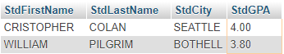

4.2

[SELECT](http://127.0.0.1/phpMyAdmin/url.php?url=https://dev.mysql.com/doc/refman/5.5/en/select.html) * FROM faculty

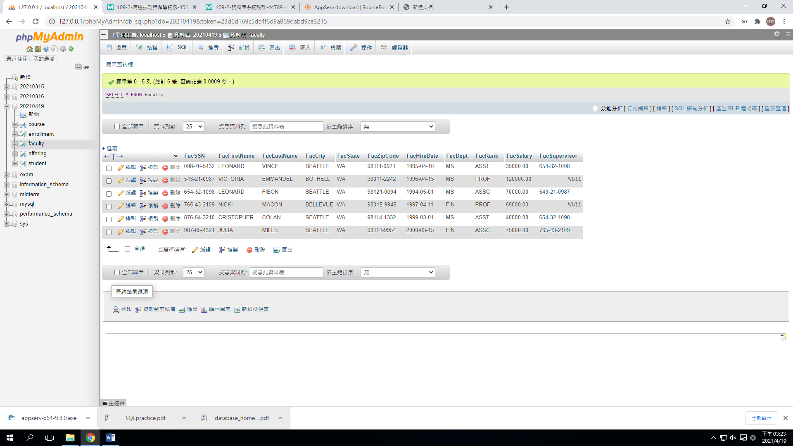

4.3

[SELECT](http://127.0.0.1/phpMyAdmin/url.php?url=https://dev.mysql.com/doc/refman/5.5/en/select.html) `FacFirstName`,`FacLastName`,`FacCity`,`FacSalary`*1.1 AS IncreasedSalary,`FacHireDate` FROM faculty WHERE [year](http://127.0.0.1/phpMyAdmin/url.php?url=https://dev.mysql.com/doc/refman/5.5/en/date-and-time-types.html)(`FacHireDate`)>1996

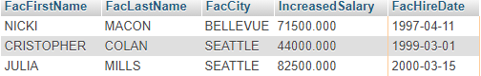

4.4

[SELECT](http://127.0.0.1/phpMyAdmin/url.php?url=https://dev.mysql.com/doc/refman/5.5/en/select.html) * FROM `course` WHERE `CourseNo` [LIKE](http://127.0.0.1/phpMyAdmin/url.php?url=https://dev.mysql.com/doc/refman/5.5/en/string-comparison-functions.html#operator_like) 'IS4*'

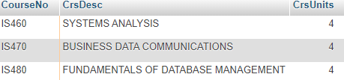

4.5

[SELECT](http://127.0.0.1/phpMyAdmin/url.php?url=https://dev.mysql.com/doc/refman/5.5/en/select.html) `FacFirstName`,`FacLastName`,`FacHireDate`FROM faculty WHERE [year](http://127.0.0.1/phpMyAdmin/url.php?url=https://dev.mysql.com/doc/refman/5.5/en/date-and-time-types.html)(`FacHireDate`)=1999 [OR](http://127.0.0.1/phpMyAdmin/url.php?url=https://dev.mysql.com/doc/refman/5.5/en/logical-operators.html#operator_or) [year](http://127.0.0.1/phpMyAdmin/url.php?url=https://dev.mysql.com/doc/refman/5.5/en/date-and-time-types.html)(`FacHireDate`)=2000



4.6

[SELECT](http://127.0.0.1/phpMyAdmin/url.php?url=https://dev.mysql.com/doc/refman/5.5/en/select.html) `OfferNo`,`CourseNo`FROM offering WHERE `FacSSN` [IS](http://127.0.0.1/phpMyAdmin/url.php?url=https://dev.mysql.com/doc/refman/5.5/en/comparison-operators.html#operator_is) NULL [AND](http://127.0.0.1/phpMyAdmin/url.php?url=https://dev.mysql.com/doc/refman/5.5/en/logical-operators.html#operator_and) `OffTerm` = 'SUMMER' [AND](http://127.0.0.1/phpMyAdmin/url.php?url=https://dev.mysql.com/doc/refman/5.5/en/logical-operators.html#operator_and) OffYear = 2006



4.7

[SELECT](http://127.0.0.1/phpMyAdmin/url.php?url=https://dev.mysql.com/doc/refman/5.5/en/select.html) `OfferNo`,`CourseNo`,`FacSSN`FROM offering WHERE(`OffTerm`='FALL'[AND](http://127.0.0.1/phpMyAdmin/url.php?url=https://dev.mysql.com/doc/refman/5.5/en/logical-operators.html#operator_and) `OffYear`= 2005)[OR](http://127.0.0.1/phpMyAdmin/url.php?url=https://dev.mysql.com/doc/refman/5.5/en/logical-operators.html#operator_or)(`OffTerm`='WINTER'[and](http://127.0.0.1/phpMyAdmin/url.php?url=https://dev.mysql.com/doc/refman/5.5/en/logical-operators.html#operator_and) `OffYear`=2006)

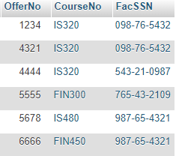

4.8

[SELECT](http://127.0.0.1/phpMyAdmin/url.php?url=https://dev.mysql.com/doc/refman/5.5/en/select.html) `OfferNo`,offering.CourseNo,`OffDays`,`OffTime` FROM `offering`,`course` WHERE `OffTerm`='SPRING' [AND](http://127.0.0.1/phpMyAdmin/url.php?url=https://dev.mysql.com/doc/refman/5.5/en/logical-operators.html#operator_and) `OffYear`=2006 [AND](http://127.0.0.1/phpMyAdmin/url.php?url=https://dev.mysql.com/doc/refman/5.5/en/logical-operators.html#operator_and)(`CrsDesc` [LIKE](http://127.0.0.1/phpMyAdmin/url.php?url=https://dev.mysql.com/doc/refman/5.5/en/string-comparison-functions.html#operator_like) '%DATABASE%' [OR](http://127.0.0.1/phpMyAdmin/url.php?url=https://dev.mysql.com/doc/refman/5.5/en/logical-operators.html#operator_or) `CrsDesc`[LIKE](http://127.0.0.1/phpMyAdmin/url.php?url=https://dev.mysql.com/doc/refman/5.5/en/string-comparison-functions.html#operator_like) '%PROGRAMMING%')[AND](http://127.0.0.1/phpMyAdmin/url.php?url=https://dev.mysql.com/doc/refman/5.5/en/logical-operators.html#operator_and) course.CourseNo=offering.CourseNo

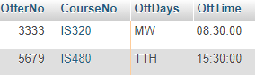

4.9

[SELECT](http://127.0.0.1/phpMyAdmin/url.php?url=https://dev.mysql.com/doc/refman/5.5/en/select.html) `OfferNo`,`CourseNo`,`FacFirstName`,`FacLastName`FROM offering,faculty WHERE OffTerm='FALL'[AND](http://127.0.0.1/phpMyAdmin/url.php?url=https://dev.mysql.com/doc/refman/5.5/en/logical-operators.html#operator_and) OffYear=2005 [AND](http://127.0.0.1/phpMyAdmin/url.php?url=https://dev.mysql.com/doc/refman/5.5/en/logical-operators.html#operator_and) FacRank='ASST' [AND](http://127.0.0.1/phpMyAdmin/url.php?url=https://dev.mysql.com/doc/refman/5.5/en/logical-operators.html#operator_and) CourseNo [LIKE](http://127.0.0.1/phpMyAdmin/url.php?url=https://dev.mysql.com/doc/refman/5.5/en/string-comparison-functions.html#operator_like) 'IS%' [AND](http://127.0.0.1/phpMyAdmin/url.php?url=https://dev.mysql.com/doc/refman/5.5/en/logical-operators.html#operator_and) faculty.FacSSN = offering.FacSSN



4.10

[SELECT](http://127.0.0.1/phpMyAdmin/url.php?url=https://dev.mysql.com/doc/refman/5.5/en/select.html) `OfferNo`, `CourseNo`,faculty.FacFirstName,faculty.FacLastName FROM `offering` INNER JOIN faculty on faculty.FacSSN =offering.FacSSN WHERE OffTerm='FALL'[AND](http://127.0.0.1/phpMyAdmin/url.php?url=https://dev.mysql.com/doc/refman/5.5/en/logical-operators.html#operator_and) OffYear =2005 [AND](http://127.0.0.1/phpMyAdmin/url.php?url=https://dev.mysql.com/doc/refman/5.5/en/logical-operators.html#operator_and) faculty.FacRank='ASST'[AND](http://127.0.0.1/phpMyAdmin/url.php?url=https://dev.mysql.com/doc/refman/5.5/en/logical-operators.html#operator_and) CourseNo [LIKE](http://127.0.0.1/phpMyAdmin/url.php?url=https://dev.mysql.com/doc/refman/5.5/en/string-comparison-functions.html#operator_like) 'IS%'



4.11

[SELECT](http://127.0.0.1/phpMyAdmin/url.php?url=https://dev.mysql.com/doc/refman/5.5/en/select.html) `StdMajor`,[AVG](http://127.0.0.1/phpMyAdmin/url.php?url=https://dev.mysql.com/doc/refman/5.5/en/group-by-functions.html#function_avg)(StdGPA)AS AvgGPA FROM student GROUP BY StdMajor

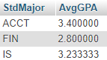

4.12

[SELECT](http://127.0.0.1/phpMyAdmin/url.php?url=https://dev.mysql.com/doc/refman/5.5/en/select.html) `OffYear`,[COUNT](http://127.0.0.1/phpMyAdmin/url.php?url=https://dev.mysql.com/doc/refman/5.5/en/group-by-functions.html#function_count)(*)AS NumOffering,[COUNT](http://127.0.0.1/phpMyAdmin/url.php?url=https://dev.mysql.com/doc/refman/5.5/en/group-by-functions.html#function_count)(DISTINCT CourseNo)AS NumCourses FROM offering GROUP BY OffYear



4.13

[SELECT](http://127.0.0.1/phpMyAdmin/url.php?url=https://dev.mysql.com/doc/refman/5.5/en/select.html) StdMajor,[AVG](http://127.0.0.1/phpMyAdmin/url.php?url=https://dev.mysql.com/doc/refman/5.5/en/group-by-functions.html#function_avg)(StdGPA)AS AvgGpa FROM student WHERE StdClass ='JR'[OR](http://127.0.0.1/phpMyAdmin/url.php?url=https://dev.mysql.com/doc/refman/5.5/en/logical-operators.html#operator_or) StdClass = 'SR' GROUP by StdMajor

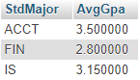

4.14

[SELECT](http://127.0.0.1/phpmyadmin/url.php?url=https://dev.mysql.com/doc/refman/8.0/en/select.html) StdMajor,[AVG](http://127.0.0.1/phpmyadmin/url.php?url=https://dev.mysql.com/doc/refman/8.0/en/group-by-functions.html#function_avg)(StdGPA)AS AvgGPA FROM student WHERE StdClass ='JR'[OR](http://127.0.0.1/phpmyadmin/url.php?url=https://dev.mysql.com/doc/refman/8.0/en/logical-operators.html#operator_or) StdClass='SR' GROUP by StdMajor HAVING [AVG](http://127.0.0.1/phpmyadmin/url.php?url=https://dev.mysql.com/doc/refman/8.0/en/group-by-functions.html#function_avg)(StdGPA)>3.1

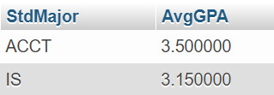

4.15

[SELECT](http://127.0.0.1/phpmyadmin/url.php?url=https://dev.mysql.com/doc/refman/8.0/en/select.html) [COUNT](http://127.0.0.1/phpmyadmin/url.php?url=https://dev.mysql.com/doc/refman/8.0/en/group-by-functions.html#function_count)(*)AS StdCnt,[AVG](http://127.0.0.1/phpmyadmin/url.php?url=https://dev.mysql.com/doc/refman/8.0/en/group-by-functions.html#function_avg)(StdGPA)as AvgGPA FROM student WHERE StdClass [in](http://127.0.0.1/phpmyadmin/url.php?url=https://dev.mysql.com/doc/refman/8.0/en/comparison-operators.html#function_in)('JR','SR')



4.16

[SELECT](http://127.0.0.1/phpmyadmin/url.php?url=https://dev.mysql.com/doc/refman/8.0/en/select.html) StdMajor,StdClass,[MIN](http://127.0.0.1/phpmyadmin/url.php?url=https://dev.mysql.com/doc/refman/8.0/en/group-by-functions.html#function_min)(stdGPA)AS MinGPA,[max](http://127.0.0.1/phpmyadmin/url.php?url=https://dev.mysql.com/doc/refman/8.0/en/group-by-functions.html#function_max)(StdGPA)AS MaxGPA FROM student GROUP BY StdMajor,StdClass

4.17

[SELECT](http://127.0.0.1/phpmyadmin/url.php?url=https://dev.mysql.com/doc/refman/8.0/en/select.html) CrsDesc,[COUNT](http://127.0.0.1/phpmyadmin/url.php?url=https://dev.mysql.com/doc/refman/8.0/en/group-by-functions.html#function_count)(*) AS OfferCount from course INNER JOIN offering on course.CourseNo=offering.CourseNo [AND](http://127.0.0.1/phpmyadmin/url.php?url=https://dev.mysql.com/doc/refman/8.0/en/logical-operators.html#operator_and) Course.CourseNo [LIKE](http://127.0.0.1/phpmyadmin/url.php?url=https://dev.mysql.com/doc/refman/8.0/en/string-comparison-functions.html#operator_like) 'IS%' GROUP BY CrsDesc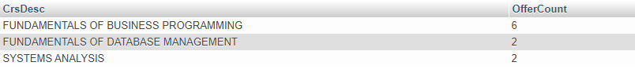

4.18

[SELECT](http://127.0.0.1/phpmyadmin/url.php?url=https://dev.mysql.com/doc/refman/8.0/en/select.html) StdGPA,`StdFirstName`,`StdLastName`,`StdCity`,`StdState`FROM student WHERE StdClass = 'JR' ORDER BY StdGPA

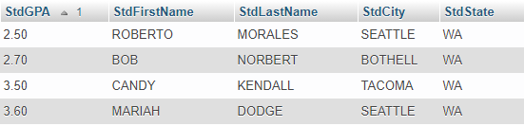

4.19

[SELECT](http://127.0.0.1/phpmyadmin/url.php?url=https://dev.mysql.com/doc/refman/8.0/en/select.html) `FacRank`,`FacSalary`,`FacFirstName`,`FacLastName`,`FacDept` FROM `faculty` ORDER BY`FacRank`,`FacSalary` DESC

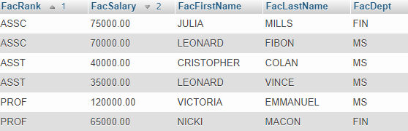

4.20

[SELECT](http://127.0.0.1/phpmyadmin/url.php?url=https://dev.mysql.com/doc/refman/8.0/en/select.html) `FacCity`,`FacState`FROM faculty

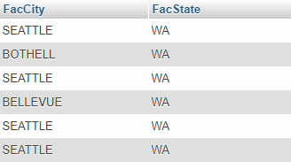

4.21

[SELECT](http://127.0.0.1/phpmyadmin/url.php?url=https://dev.mysql.com/doc/refman/8.0/en/select.html) DISTINCT`FacCity`,`FacState`FROM faculty

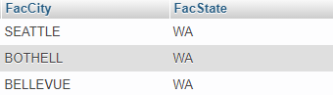

4.22

[SELECT](http://127.0.0.1/phpmyadmin/url.php?url=https://dev.mysql.com/doc/refman/8.0/en/select.html) offering.CourseNo, offering.OfferNo,[AVG](http://127.0.0.1/phpmyadmin/url.php?url=https://dev.mysql.com/doc/refman/8.0/en/group-by-functions.html#function_avg)(enrollment.EnrGrade)AS AvgGrade FROM enrollment ,offering WHERE offering.CourseNo [LIKE](http://127.0.0.1/phpmyadmin/url.php?url=https://dev.mysql.com/doc/refman/8.0/en/string-comparison-functions.html#operator_like) 'IS%' [AND](http://127.0.0.1/phpmyadmin/url.php?url=https://dev.mysql.com/doc/refman/8.0/en/logical-operators.html#operator_and) offering.OffYear = 2005 [and](http://127.0.0.1/phpmyadmin/url.php?url=https://dev.mysql.com/doc/refman/8.0/en/logical-operators.html#operator_and) offering.OffTerm ='FALL'[AND](http://127.0.0.1/phpmyadmin/url.php?url=https://dev.mysql.com/doc/refman/8.0/en/logical-operators.html#operator_and) enrollment.OfferNo = offering.OfferNo GROUP by CourseNo,offering.OfferNo HAVING [COUNT](http://127.0.0.1/phpmyadmin/url.php?url=https://dev.mysql.com/doc/refman/8.0/en/group-by-functions.html#function_count)(*)>1 ORDER BY CourseNo DESC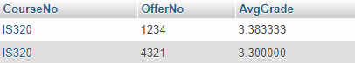

4.23

[SELECT](http://127.0.0.1/phpmyadmin/url.php?url=https://dev.mysql.com/doc/refman/8.0/en/select.html) student.StdFirstName,student.StdLastName,enrollment.OfferNo,enrollment.EnrGrade FROM student NATURAL JOIN enrollment WHERE enrollment.EnrGrade>=3.5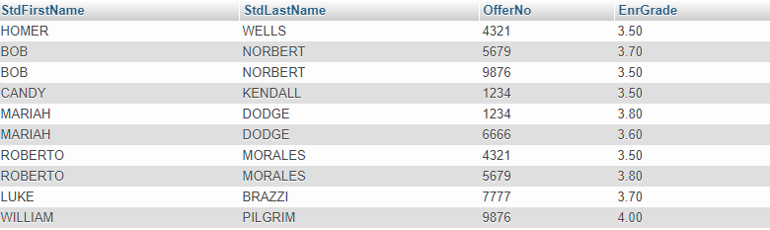

4.24

[SELECT](http://127.0.0.1/phpmyadmin/url.php?url=https://dev.mysql.com/doc/refman/8.0/en/select.html) student.StdFirstName,student.StdLastName FROM student NATURAL JOIN enrollment WHERE enrollment.EnrGrade>=3.5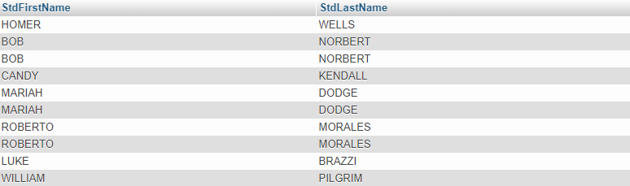

4.25

[SELECT](http://127.0.0.1/phpmyadmin/url.php?url=https://dev.mysql.com/doc/refman/8.0/en/select.html) DISTINCT student.StdFirstName,student.StdLastName FROM student NATURAL JOIN enrollment WHERE enrollment.EnrGrade>=3.5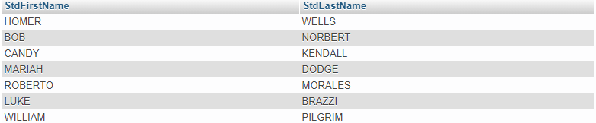

4.26

[SELECT](http://127.0.0.1/phpmyadmin/url.php?url=https://dev.mysql.com/doc/refman/8.0/en/select.html) student.StdFirstName,student.StdLastName,enrollment.OfferNo FROM student NATURAL JOIN enrollment NATURAL JOIN offering WHERE offering.OffYear =2005 [AND](http://127.0.0.1/phpmyadmin/url.php?url=https://dev.mysql.com/doc/refman/8.0/en/logical-operators.html#operator_and) offering.OffTerm='FALL' [AND](http://127.0.0.1/phpmyadmin/url.php?url=https://dev.mysql.com/doc/refman/8.0/en/logical-operators.html#operator_and) enrollment.EnrGrade>=3.7



4.27

[SELECT](http://127.0.0.1/phpmyadmin/url.php?url=https://dev.mysql.com/doc/refman/8.0/en/select.html) offering.OfferNo,course.CourseNo,course.CrsUnits,offering.OffDays,offering.OffLocation,offering.OffTime FROM faculty NATURAL JOIN offering NATURAL JOIN course WHERE offering.OffYear=2005 [AND](http://127.0.0.1/phpmyadmin/url.php?url=https://dev.mysql.com/doc/refman/8.0/en/logical-operators.html#operator_and) offering.OffTerm='FALL' [AND](http://127.0.0.1/phpmyadmin/url.php?url=https://dev.mysql.com/doc/refman/8.0/en/logical-operators.html#operator_and) faculty.FacFirstName='LEONARD' [AND](http://127.0.0.1/phpmyadmin/url.php?url=https://dev.mysql.com/doc/refman/8.0/en/logical-operators.html#operator_and) faculty.FacLastName='VINCE'



4.28

[SELECT](http://127.0.0.1/phpmyadmin/url.php?url=https://dev.mysql.com/doc/refman/8.0/en/select.html) offering.OfferNo,offering.CourseNo,offering.OffDays,offering.OffLocation, offering.OffTime,faculty.FacFirstName,faculty.FacLastName FROM offering NATURAL JOIN faculty NATURAL JOIN student NATURAL JOIN enrollment WHERE offering.OffYear=2006 [AND](http://127.0.0.1/phpmyadmin/url.php?url=https://dev.mysql.com/doc/refman/8.0/en/logical-operators.html#operator_and) offering.OffTerm='SPRING' [AND](http://127.0.0.1/phpmyadmin/url.php?url=https://dev.mysql.com/doc/refman/8.0/en/logical-operators.html#operator_and) student.StdFirstName ='BOB'[AND](http://127.0.0.1/phpmyadmin/url.php?url=https://dev.mysql.com/doc/refman/8.0/en/logical-operators.html#operator_and) student.StdLastName='NORBERT'

4.29

[SELECT](http://127.0.0.1/phpmyadmin/url.php?url=https://dev.mysql.com/doc/refman/8.0/en/select.html) offering.OfferNo,offering.CourseNo,offering.OffDays,offering.OffLocation, offering.OffTime,faculty.FacFirstName,faculty.FacLastName FROM offering NATURAL JOIN faculty NATURAL JOIN student NATURAL JOIN enrollment NATURAL JOIN course WHERE offering.OffYear=2006 [AND](http://127.0.0.1/phpmyadmin/url.php?url=https://dev.mysql.com/doc/refman/8.0/en/logical-operators.html#operator_and) offering.OffTerm='SPRING' [AND](http://127.0.0.1/phpmyadmin/url.php?url=https://dev.mysql.com/doc/refman/8.0/en/logical-operators.html#operator_and) student.StdFirstName ='BOB'[AND](http://127.0.0.1/phpmyadmin/url.php?url=https://dev.mysql.com/doc/refman/8.0/en/logical-operators.html#operator_and) student.StdLastName='NORBERT'



4.30

[SELECT](http://127.0.0.1/phpmyadmin/url.php?url=https://dev.mysql.com/doc/refman/8.0/en/select.html) student.* FROM student, faculty WHERE student.StdSSN = faculty.FacSSN

4.31

[SELECT](http://127.0.0.1/phpmyadmin/url.php?url=https://dev.mysql.com/doc/refman/8.0/en/select.html) StdFirstName,StdLastName,StdCity,enrollment.EnrGrade FROM student NATURAL JOIN enrollment WHERE enrollment.EnrGrade>=3.5

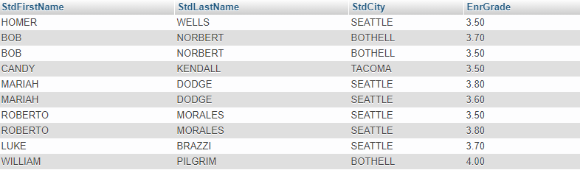

4.32

[SELECT](http://127.0.0.1/phpmyadmin/url.php?url=https://dev.mysql.com/doc/refman/8.0/en/select.html) StdFirstName,StdLastName,StdCity,enrollment.EnrGrade FROM student NATURAL JOIN enrollment NATURAL JOIN offering WHERE enrollment.EnrGrade>=3.5 [AND](http://127.0.0.1/phpmyadmin/url.php?url=https://dev.mysql.com/doc/refman/8.0/en/logical-operators.html#operator_and) offering.OffTerm ='FALL' [AND](http://127.0.0.1/phpmyadmin/url.php?url=https://dev.mysql.com/doc/refman/8.0/en/logical-operators.html#operator_and) offering.OffYear=2005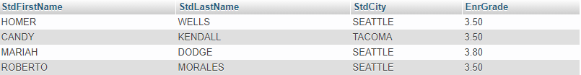

4.33

[SELECT](http://127.0.0.1/phpmyadmin/url.php?url=https://dev.mysql.com/doc/refman/8.0/en/select.html) StdFirstName,StdLastName,StdCity,enrollment.EnrGrade FROM student NATURAL JOIN enrollment NATURAL JOIN offering NATURAL JOIN faculty WHERE enrollment.EnrGrade>=3.5 [AND](http://127.0.0.1/phpmyadmin/url.php?url=https://dev.mysql.com/doc/refman/8.0/en/logical-operators.html#operator_and) offering.OffTerm ='FALL' [AND](http://127.0.0.1/phpmyadmin/url.php?url=https://dev.mysql.com/doc/refman/8.0/en/logical-operators.html#operator_and) offering.OffYear=2005 [AND](http://127.0.0.1/phpmyadmin/url.php?url=https://dev.mysql.com/doc/refman/8.0/en/logical-operators.html#operator_and) faculty.FacFirstName='LEONARD'[AND](http://127.0.0.1/phpmyadmin/url.php?url=https://dev.mysql.com/doc/refman/8.0/en/logical-operators.html#operator_and) faculty.FacLastName='VINCE'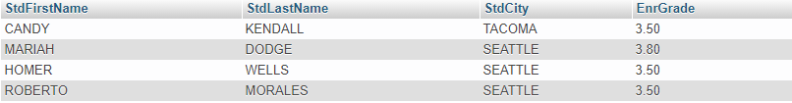

4.34

[SELECT](http://127.0.0.1/phpmyadmin/url.php?url=https://dev.mysql.com/doc/refman/8.0/en/select.html) StdFirstName,StdLastName,StdCity,enrollment.EnrGrade FROM student NATURAL JOIN enrollment NATURAL JOIN offering NATURAL JOIN faculty WHERE enrollment.EnrGrade>=3.5 [AND](http://127.0.0.1/phpmyadmin/url.php?url=https://dev.mysql.com/doc/refman/8.0/en/logical-operators.html#operator_and) offering.OffTerm ='FALL' [AND](http://127.0.0.1/phpmyadmin/url.php?url=https://dev.mysql.com/doc/refman/8.0/en/logical-operators.html#operator_and) offering.OffYear=2005 [AND](http://127.0.0.1/phpmyadmin/url.php?url=https://dev.mysql.com/doc/refman/8.0/en/logical-operators.html#operator_and) faculty.FacFirstName='LEONARD'[AND](http://127.0.0.1/phpmyadmin/url.php?url=https://dev.mysql.com/doc/refman/8.0/en/logical-operators.html#operator_and) faculty.FacLastName='VINCE'